Psychiatry Clerkship Manual
Academic Year 2023-2024

Clerkship Leadership and Staff
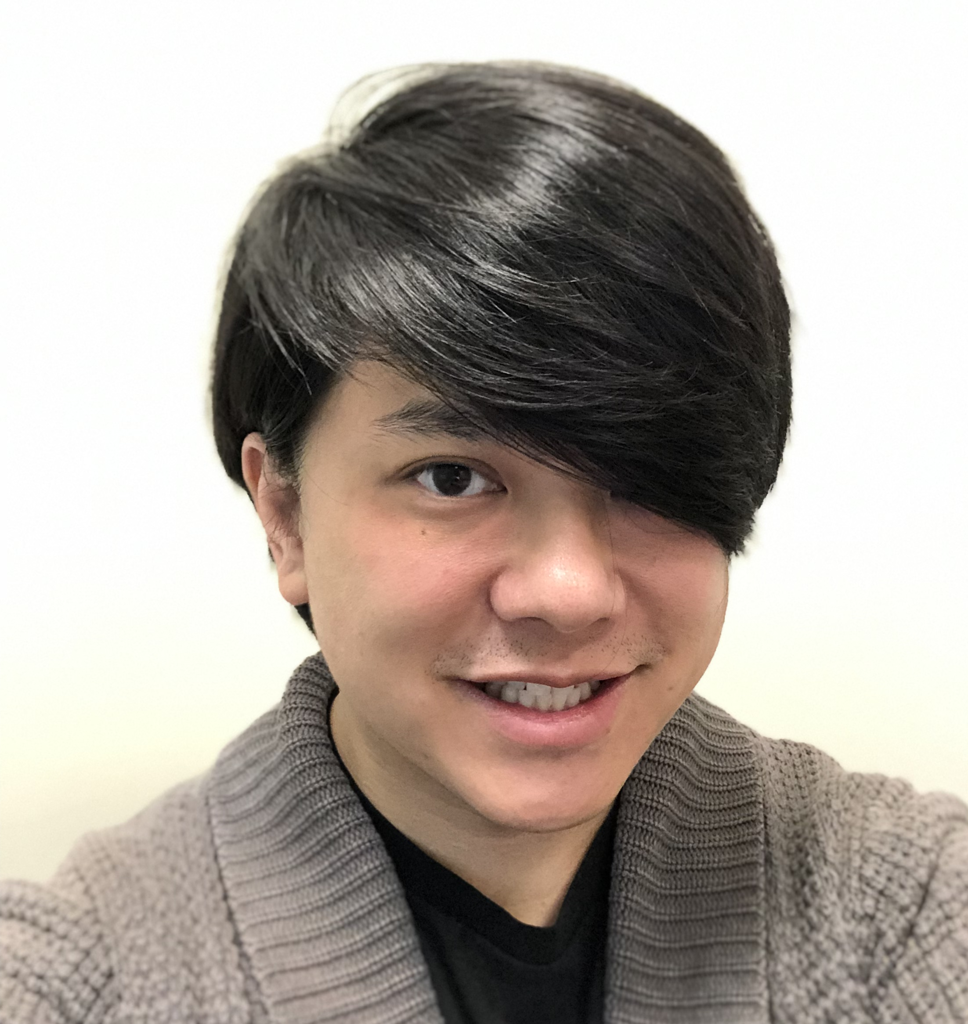  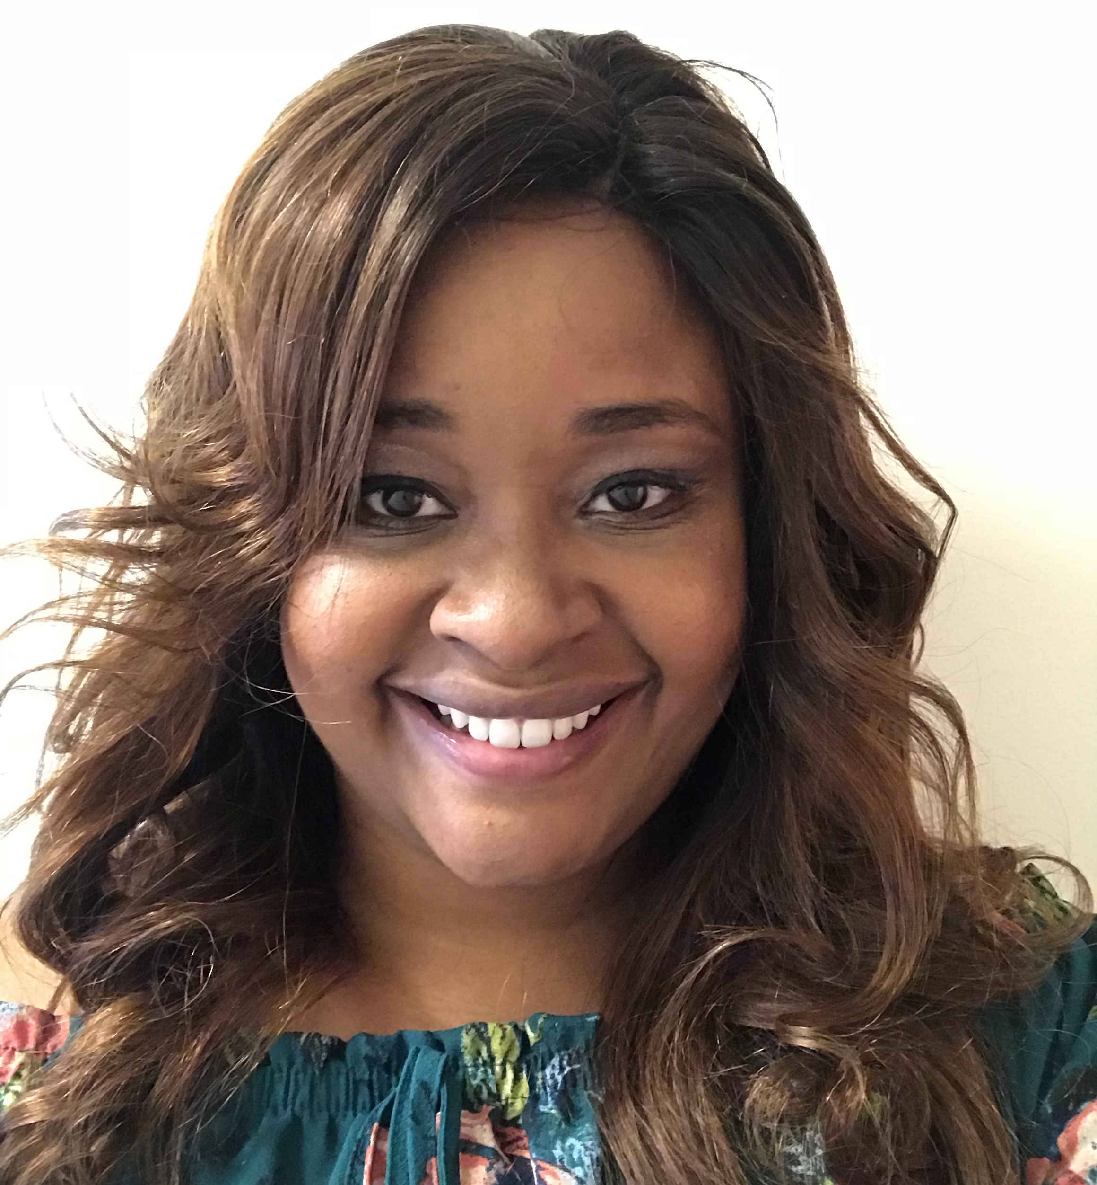  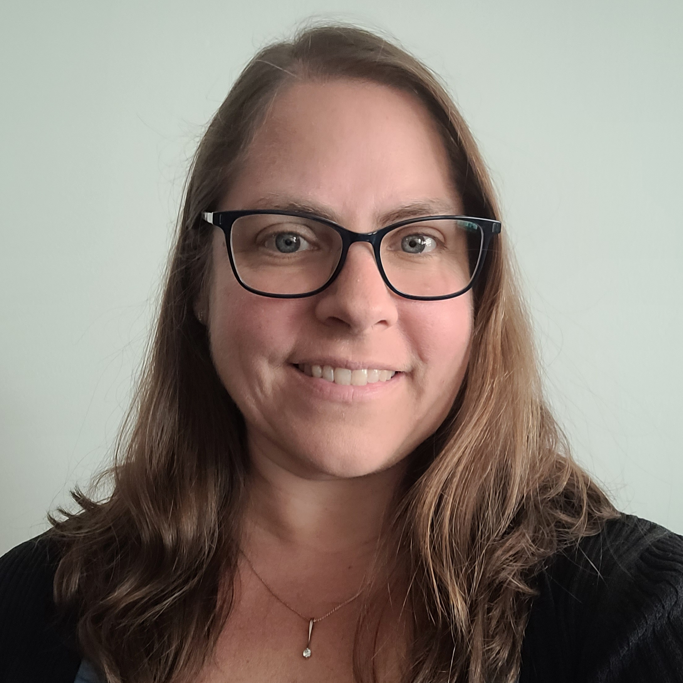 | Kai-Hong Mao, M.D.  Clerkship Director  (o) 323-409-2949  (p) 323-372-7635  (c) 515-577-8588  kai-hongjeremy.mao@med.usc.edu  Sabrina Reed, M.D.  Assistant Clerkship Director  (p) 213-208-2336  (c) 708-822-1196  Sabrina.Reed@med.usc.edu  Lorrie Peña, M.Ed.  Clerkship Coordinator  (c) 520-609-4009  Lorrie.Pena@med.usc.edu
Table of Contents
Introduction………………………………………………………………………………………...2
Psychiatry Clerkship Goals……………………………………………………………………...... 2
Psychiatry Clerkship Objectives………………………………………………………………...... 2
Psychiatry Clerkship Structure…………………………………………………………………….3
Clerkship Site Descriptions………………………………………………………………...............3
Clerkship Learning Activities…………………………………………………………………...... 3
Clerkship Required Assignments…………………………………………………………………..5
Clerkship Learning Resources……………………………………………………………………. 6
Student Assessment.. .……………………………………………………………………………..6
EHR Access and Emergency Protocols……………………………………………………………8
Policies……………………………………………………………………………………………..9

Introduction
Welcome to the Psychiatry Clerkship! We hope that you find it clinically stimulating, useful for your professional development, informative for learning, and fun. The following information is provided to help orient you to the clerkship. It includes some general survival information, learning objectives, evaluation policies, and schedules. The clerkship provides extensive patient contact in both inpatient and outpatient settings, lectures, and conferences. We hope to foster within you a better understanding of how mental health issues influence our patients’ overall health and perhaps we’ll even inspire you to pursue a career in psychiatry!
Please note that you are responsible for knowing and following the Keck School of Medicine Student Policies.

Psychiatry Clerkship Goals
The diversity of learning experiences on the psychiatry clerkships will provide you with rich opportunities to learn about and from your patients. The following are the goals of this clerkship:
- Recognize and technically describe syndromes, such as anxiety, depression, psychosis, substance use disorders and mental syndromes due to a general medical condition.
- Demonstrate empathy for mentally ill patients through consideration of transference/counter transference issues as well as one's own biases.
- Develop an appreciation for a psychiatrist’s role and responsibility in advocating for the needs of patients (individuals and populations) within society.
- Develop an appreciation for unique ethical challenges within psychiatry: unique ethical dilemmas for patients who refuse any kind of care or treatment; being confronted with the need to place the patient on involuntary hold; the responsibility for making ethical decisions in complex and potentially risky medical problems; identifying alternatives in difficult ethical choices and analyze conflicting considerations.
- Develop habits of life-long learning (using reflective exercises that incorporate feedback and self-assessment), and commit to ongoing self-evaluation and life-long learning to
improve patient care.
- Develop an appreciation for the impact of culture, diversity, and the structural components of patient and community environments on patients' health and the doctor/patient relationship.
- Collaboratively work with members of an interprofessional team towards the enhancement of patient safety in all respects so that the quality of patient care is optimal.

Psychiatry Clerkship Objectives

The clerkship objectives support achievement of the KSOM Educational Program Objectives: https://medstudent.usc.edu/academics/ksom-educational-program-objectives/.
By the end of the Psychiatry clerkship, students will be able to do the following in simulated, virtual, or in-person clinical settings:
- Elicit relevant historic information and symptom descriptions, while taking into consideration cultural, ethnic, and gender issues in a sensitive manner.
- Present a differential diagnosis for psychiatric disorders which are characterized by a given psychiatric syndrome.
- Perform a comprehensive mental status exam, consisting of relevant observations and tests.
- Present a psychiatric case in an organized fashion, describing relevant history, results of a mental status exam, relevant findings and laboratory studies, a well-structured basic differential diagnosis, a brief case discussion, and treatment recommendations using the biopsychosocial model.
- Demonstrate sound critical reasoning when determining whether or not to place a patient on an involuntary psychiatric hold.
- Practice and integrate effective verbal and non-verbal communication skills with patients and their families during clinical encounters.
- Effectively communicate with other medical and paramedical personnel involved in patient care.
- Demonstrate an understanding of the specific needs of patients in acute psychiatric clinical settings.
- Effectively identify indications and treatment protocols for major classes of psychiatric medications and major types of psychotherapies during treatment planning.
- Demonstrate foundational basic science and clinical knowledge of a broad range of psychiatric problems relating to patients with mental health complaints.
- Prepare concise, case-based write-ups of a patient encounter(s).
- Effectively use medical literature, computer-based searching tools, and other informational resources in the care of patients.

Clerkship Structure
The Psychiatry Clerkship is four weeks in duration, during which time students are involved in activities in which they gain valuable clinical experience, extensive supervision and participate in a wide range of educational activities. Rotations may include experiences in inpatient, consultation-liaison (also known as psychosomatic medicine), emergency, and outpatient psychiatric settings amongst others. Possible clerkship sites include LAC+USC Medical Center, Keck Hospital, and community hospitals. Students should expect to work with a wide range of populations including those of different age, ethnic, cultural, gender, sexual, and social-economic backgrounds.

Clerkship Site Descriptions
Clerkship site descriptions can be viewed at the following website: https://medstudent.usc.edu/clerkship-site-descriptions/.

Clerkship Learning Activities
Students will participate in activities designed to enhance a student’s cultural and clinical awareness through bio-psycho-sociocultural treatment planning and engage in an ethics seminar targeted to broaden one’s understanding of medical-legal dilemmas. Students may also visit and observe clinical practice in an electroconvulsive therapy (ECT) clinic.

Specific targets for skill acquisition include: 1) interviewing*, 2) diagnosis, 3) differential diagnosis specifically on medical/surgical/substance/culture and other issues, 4) bio-psycho-socio-cultural treatment planning, 5) working in an interdisciplinary team, 6) safety, 7) ethical decision making, 7) wellness, and 8) joint decision-making with patients/family/community staff.

*Within the category of Interviewing, the Suicide Risk Assessment administration is critically important and will be emphasized in lecture and on-site observation.

Wellness Day – Students will have a ½ day off for Wellness. Please see the provided rotation-specific calendar for the Wellness Day date.

- Clinical Rotation – Students will see new patients for H&Ps as well as follow-up cases with their attending/faculty, residents (most services), other members of the interdisciplinary team, and allied health staff. Students are assessed based on the objectives in the Medical Student Evaluation form.

Preparation/To Do – Obtain templates, if available, from services as a guide to write notes. There are basic ingredients in most all notes, but some nuances for most sites. During week 2 print and give one H&P to your preceptor in order to obtain general feedback and adjust to site- or other-based criteria. Obtain informal or written feedback, if possible.
- Didactics Series – All seminars are held on Tuesdays from 1:15 to 5:30 p.m. via Zoom. Attendance is mandatory.
- Ethics Seminar – Clinical Ethics in Psychiatry has unique features to consider that may not be present in another setting. Because of the nature of psychiatric illness, there may be: distortion of thinking, feeling, and perception; odd or disorganized behavior; erosion of relationships; changes in societal role; and changes of perception of self. Psychiatric patients suffer in some common and individual ways.

Basic ethical principles will be useful to bring knowledge, experience and understanding to the ethics seminar. It will focus on group discussions of ethical situations encountered in the clinical setting and how one’s individual experiences may affect outcomes. Often, ethical problems occur when working with patients refusing treatment. The involuntary hold will be part of the discussion along with other examples that may be encountered in medicine in general. Students will be encouraged to elicit thoughts and opinions of working psychiatrists in relation to the awesome responsibility that often falls upon the physician when ethically challenging situations occur. This will help with understanding one’s own philosophy in response to being the decision maker.
- Outpatient Experience – Each student will be assigned at least one half day experience in a psychiatric outpatient clinic in order to broaden their understanding of the clinical care that can be provided by psychiatrists. Clinical care that students engage in could be in one of several integrated care settings (reproductive medicine, HIV, geriatric, med-peds, early childhood, and mother-child). Students will be expected to work with the attending, fellows, and/or residents that are at these clinical sites and participate in treatment planning. Students could also be involved in direct patient care depending on comfort level. Additionally, students are expected to present to their primary clinical rotation during the second half of their assigned outpatient day.
- Psychiatric ER Experience – Each student may* have the opportunity to spend ½ day observing psychiatric care in the psychiatric emergency room. The experience will be facilitated by the psychiatry chief resident or an attending psychiatrist. They will accompany you in evaluating acute psychiatric patients, during which you’ll learn more about unique issues that present in this acute care setting. Specific safety strategies will be explained and compliance with these regulations is mandatory. Your specific goals when visiting the Psychiatric ER are to observe patients presenting with severe psychotic symptoms, depressive, such as severe neurovegetative or manic symptoms, and the appropriate use of restraints with faculty supervision.
Preparation/To Do – The Legal Issues and Emergencies in Psychiatry lecture is a pre-requisite for this experience. This will help students gain an understanding of how to ensure safety in the Psychiatric Emergency Room and the Suicide Risk Assessment.
*The Psychiatric ER Experience may be suspended and/or re-instated depending on safety and health considerations/regulations in the Emergency Room.
- Culture and Diversity Awareness – This is a fundamental part of the Clerkship and medical practice in general. It also fits with our dedication to, and care for, patients/families and the community. By assessing patients in a culturally aware manner with a keen understanding of what makes our patients unique, we lay the groundwork for excellent patient care.
- Department Grand Rounds – Tuesday Grand Rounds for Psychiatry will take place from 12:00 p.m. to 1:00 p.m. in the Clinical Sciences Building (CSC) on the 2nd floor in the Harkness Auditorium or via Zoom. Attending these presentations is elective but encouraged. Please check with faculty and residents for ones geared for your learning.
- Site-based Conferences and Other Educational Activities – Many, not all, sites have their own grand rounds, didactics for trainees, case conferences, and opportunities for trainees to present. Ask during your site-specified orientation whether or not you will be required to make a presentation.
- ECT – Students (except for those at Kaweah Delta and Cottage Hospital) may* spend one morning during the rotation observing electroconvulsive therapy. Students should arrive promptly at 8:30 a.m. at the USC Keck Hospital. Go to the 3rd Floor, Suite 3205. The ECT Nurse, Michell Fang will give you some material to read before the session. The experience will last approximately 2 hours.
*The ECT Experience may be suspended and/or re-instated depending on safety and health considerations/regulations at the Keck Hops.

Clerkship Required Assignments
Required Clinical Experiences – The following Required Clinical Experiences cases for the psychiatry clerkship are:
- *Depressive Disorders
- *Bipolar Disorders
- *Anxiety Disorders
- *Trauma/Stressor-related Disorders
- *Psychotic Disorders
- *Somatic Symptom and Related Disorders
- *Substance Abuse/Addiction Disorders
- *Eating Disorders
- *Personality Disorders
- *Adverse Effects of Psychiatric Medications
*Denotes a Required Clinical Experience that is “OSCE-eligible”. The end of clerkship OSCE cases will be derived from these RCEs.

Clinical Passport – Students will keep a case log of the Required Clinical Experience cases, which must be signed off by an attending or resident/fellow after the student has seen or discussed a case pertaining to that diagnosis. If a student is unable to encounter a live case, they may engage in a discussion with their attending about an online module in order to get that diagnosis or condition signed off on.

Preparation/To Do: Students will be given a weekly schedule with daily activities meant to provide students with psychiatric education specific to Required Clinical Experiences psychiatric diagnoses and will meet Clerkship objectives. Students are responsible for knowing and following the schedule set by the Clerkship Director. All scheduled lectures and activities are mandatory unless otherwise specified.

Clerkship Learning Resources
Suggested Reading
Nancy C. Andreasen, M.D., Ph.D., Donald Black, M.D., Introductory Textbook of Psychiatry, 6th Edition, 2014.

Additional Resources
  - Janis L. Cutler, M.D. and Eric Marcus, M.D., Psychiatry, 3rd Edition, 2014.
  - Diagnostic and Statistical Manual 5 (DSM-5), 5th Edition, American Psychiatric Association, 2013.
  - Desk Reference to Diagnostic Criteria for DSM 5, APA, 2013.

Secure Storage and Study Space
Secure storage and study space is available but varies by site. Ask during your site-specified orientation for available storage and study space.

Student Assessment
Evaluation and Grading
All clerkship activities, assignments, and evaluations are required and must be completed before you receive your final grade:
Graded Component | Weight
- Clinical Performance (completed by your preceptor/resident) | 55%
- NBME Psychiatry Subject Exam  Note: minimum score required to pass exam = 72. | 25%
- OSCE | 15%
- Administrative Professionalism (one point will be given for each of the following):  - Logging ALL Required Clinical Encounter cases per clerkship stated deadline.  - Completing ALL administrative tasks (e.g. evaluations) of clerkship on time.  - Completing ALL assignments on time and to satisfaction.  - Being present at ALL required activities of the clerkship.  - Responding to all communications from the clerkship leadership within 48 hours. | 5%
- Other:  - All Required Clinical Encounter reports/logs  - Mid-Rotation Feedback/Goals  - Oral examination | Satisfactory completion required

The final clerkship grade is determined by your overall score, rounded to the nearest whole number, and students must also achieve a minimum NBME score for a final grade of Pass, High Pass or Honors:
Psychiatry
 | Overall Score cut off for each grade | Minimum NBME Subject Exam Score for Grade of Pass, High Pass or Honors
Honors | 94+ | 70
High Pass | 77 - 93
Pass | 69 - 76
Fail | 68 or below

Eligibility Criteria for Faculty Supervisors to Submit an Evaluation of Student Performance: Each site will have one designated faculty member identified by the Clerkship to complete medical student evaluations. This faculty member will complete evaluations on all students rotating through the clerkship site regardless of whether or not the student worked with them during the majority of their time spent on rotation. Though the designated faculty member does typically fulfill the role as the student’s main supervisor, it should be noted that all faculty are expected to incorporate input from residents/fellows and other faculty members to accurately complete the student’s evaluation. This will help ensure that the student’s final evaluation will truly be representative of the student’s overall performance. Also note that residents and fellows do not submit independent evaluations of the medical students. KSOM health professionals who provide health and psychiatric/psychological services to a medical student cannot be involved in the academic assessment or promotion of the medical student receiving those services. Please see the Supervision of Student Performance by Healthcare Providers policy for more information.

OSCE and NBME Subject Exam Logistics: The Psychiatry Clerkship OSCE and NBME subject exam will take place on Friday during Week 4 of the rotation. The OSCE will consist of two stations that focus on primary care skills used in Psychiatry. Each station will consist of a 15-minute standardized patient encounter followed by a 10-minute post-encounter exercise. Detailed instructions will be provided to you the week before the OSCE.

Clinical Performance Assessment (CPA) – During the clinical rotation the student will set up an appointment with their clinical supervisor or resident/fellow for a structured, board-style CPA. The CPA is meant to be used by the faculty supervisor to aid in the assessment of the student’s clinical skills at the end of the rotation. The evaluation sheet titled “Clinical Performance Assessment” has been included in the students’ orientation materials and should be given to the faculty member who is doing the evaluation. When completed it must be uploaded to medOasis.

Mid-Rotation Feedback: Mid-Rotation Feedback: Mid-Rotation feedback enables students to assess their progress to date and to develop goals for growth and improvement over the remainder of the rotation. It also helps to ensure that the students can learn from and improve from practice; the supervising faculty/residents and the students must participate in a mid-rotation feedback exercise. The student will first complete a self-evaluation, provide comments, and identify learning goals they would like to accomplish before the end of the clerkship. Students are responsible for giving the attending the feedback form and arranging a time to receive individual feedback.Once completed, students must upload an electronic copy to Elentra.

Administrative Professionalism – Five percent of a student’s grade will be derived by their professional conduct during their time on the clerkship. A general rubric has been provided below to outline how professionalism points are usually earned. Points will be deducted if any component has not been successfully completed or observed. Please note that reasons for deductions are not limited to this list and the clerkship director reserves the ability to deduct points for any notable lapses in professionalism.
- Logging ALL required clinical encounters cases per clerkship stated deadline. (20%)
  - SPP Caselog (10%)
  - MedOASIS Entries (10%)
- Completing ALL administrative tasks (e.g. evaluations) of clerkship on time. (20%)
  - Mid-Rotation Feedback (10%)
  - Clinical Performance Assessment (10%)
- Completing ALL assignments on time and to satisfaction. (20%)
  - Ethics Pre-test (10%)
  - Ethics Post-test (10%)
- Being present at ALL required activities of the clerkship. (20%)
  - Present for didactics or workshop (20%)
  - Present on video during didactics (20%)
- Responding to all communications from the clerkship leadership within 48 hours. (20%)
  - Responds to all emails and communications within 48 hours (20%)

Passing the Clerkship: To receive a passing grade (Pass, High Pass, or Honor) for the clerkship, students must demonstrate minimum competence based on their 1) overall clerkship performance; 2) the NBME subject exam performance; 3) the satisfactory completion of all required activities; and 4) the absence of unprofessional behaviors as outlined in the student handbook. Note: Unexcused absence or other unprofessional conduct will preclude a final grade of Honors regardless of overall performance score.
- Students who do not pass the NBME subject exam on their first attempt will be ineligible for Honors.
- Students who pass the retake exam (second attempt) are ineligible for Honors and will receive a grade of Pass (P) or High Pass (HP) based on their overall performance.
- Students who fail the retake exam (second attempt) will continue to have a grade of Incomplete (I) noted on their transcript for that clerkship and will be required to sit for a second retake (third attempt) of the NBME subject exam.
- Students who pass the second retake exam (third attempt) are ineligible for a grade of HP or Honors and will receive a grade of “Pass” for the clerkship.
- Students who fail the second retake exam (third attempt) will receive a grade of “Fail” (F) for the clerkship and must repeat the clerkship.

Note: A student must earn 4/5 professionalism points in order to achieve the Honors distinction.

Fail: A grade of fail may be given in the following situations: 1) failure to demonstrate minimum competence based on overall clerkship performance, 2) inability to pass the NBME on three attempts, 3) any unprofessional behavior as outlined in the student handbook, 4) failure to resolve a grade of incomplete.

Incomplete: Not a final grade, but a designation that is used if a student has been excused from meeting a clerkship deadline. Designations of “Incomplete” will be assigned to any student who does not complete any required component of the clerkship. Designations of “Incomplete” will be assigned to any student who has not achieved the minimum NBME Subject Exam score set for passing the clerkship on their first and second attempts.

EHR Access and Emergency Protocols
Electronic Health Record Access
If you have questions or issues with access to the electronic health record system at Keck Hospital or LAC+USC, please contact the Office of Student Affairs at 323-442-2553. For other sites, please contact the site coordinator.

Emergency Procedures
Contact Student Affairs
If you have an urgent issue that requires assistance, you may contact the Office of Student Affairs for assistance at 323-442-2553. You can call this number after hours and be connected to the Dean on call.

Clerkship Director/MSE/Site Director/Coordinator
You can also reach out to the Clerkship Director, Medical Student Educator or Site Director for assistance.

Needlestick and Exposure Protocol
Call During Business Hours: 213-740-9355 (WELL); After Hours: (323) 442-7900. Please leave a voicemail. There is a provider available 24/7 who will return your call. More information can be found at https://engemannshc.usc.edu/bloodborne-pathogen-exposure/.

Additional information on emergency procedures can be found at:
https://medstudent.usc.edu/emergency/

Clerkship Policies
Select policies related to the clinical years are highlighted below. Please refer to the student handbook for all medical student policies and procedures: https://medstudent.usc.edu/academics/policies/

Code of Professional Behavior

Students are expected to adhere to the Code of Professional Behavior in all settings by demonstrating honesty and integrity, responsibility, reliability, and accountability as well as respect for all patients, peers, faculty, and staff. For a detailed description of various dimensions of professionalism, please review: https://medstudent.usc.edu/home/faculty-staff-information/keck-school-of-medicine-code-of-professional-behavior-and-professional-behavior-expectations/

Clerkship Evaluation
We rely on your thoughtful and constructive feedback to continually improve the curricula and instruction. Completing evaluations is a professional expectation of medical students’ professional responsibility. Please refer to the Evaluation Completion Policy.

Grade Appeals
Information about appealing a grade or evaluation can be found in the Evaluation and Grade Appeal Policy. Evaluation and grade appeals have timelines and requirements.

HIPAA Privacy Regulation
Please note that HIPAA privacy regulations are always in effect in all clinical settings. Individual practitioners (including medical students) are held personally responsible for violations of HIPAA regulations which may result in financial and other penalties. You have previously completed a HIPAA training on Trojan Learn and have access to the training modules if you wish to review them. You can also find additional information by visiting https://ooc.usc.edu/data-privacy/health-information/hipaa-privacy-regulations/

Medical Student Supervision Policy
Students must have an identified faculty supervisor at all times. Students may be directly or indirectly supervised by faculty members and/or residents and, when indirectly supervised, direct supervision must be immediately available at all times by a faculty member or resident. Please review the Medical Student Supervision Policy for more information.

Medical Student Time Requirements
Student hours include the following limits: a maximum of 28 consecutive hours in the hospital and a maximum of 80 hours per week averaged over four weeks. Students receive at least one day off per week. Refer to your individual calendar. Please review the Medical Student Time Requirements for Clinical and Education Activities Policy for more information.

Code of Conduct in Faculty-Student Relationship

The faculty code of conduct includes language about the standard of conduct in the faculty-student relationship:

https://policy.usc.edu/wp-content/uploads/2022/10/Faculty-Handbook-2022.pdf

Assessment and Supervision of Student Performance by Healthcare Providers
KSOM health professionals who provide health and psychiatric/psychological services to a medical student cannot be involved in the academic assessment or promotion of the medical student receiving those services: https://medstudent.usc.edu/faculty-staff-information/assessment-and-supervision-of-student-performance-by-healthcare-providers/

Attendance
It is the responsibility of the student to communicate with the curriculum office regarding absences from required events that result from anticipated conflicts or personal emergencies or unforeseen events. Please review the KSOM attendance policy for more details: https://medstudent.usc.edu/home/faculty-staff-information/keck-school-of-medicine-medical-student-attendance-expectations-and-absence-request-policy/

Requesting Time Off
Students requesting an excused absence for one or more missed classes, or who need to seek a leave of absence, are instructed to submit the appropriate form, which can be found here: https://medstudent.usc.edu/forms/

Access to Health Care Services
Students are excused from classes or clinical activities to access needed healthcare services. Please review the Students Needing Access to Healthcare Policy.

Computer-based Exam Administration

Students are required to bring fully charged laptops and chargers to participate in all pre-clerkship course examinations that are administered electronically. No additional items (cell phones, purses, notes, etc.) are allowed in the examination area and their presence in the examination area might result in a grade of fail for the course. For more information on the administration of computer-based examinations, please refer to: https://medstudent.usc.edu/home/faculty-staff-information/keck-school-of-medicine-md-student-policy-on-computer-based-written-examination-administration/

Mistreatment

The Keck School of Medicine (KSOM) is committed to maintaining and promoting a respectful learning environment for all members of the Keck community. KSOM has as zero tolerance policy for mistreatment. For more details on what constitutes mistreatment and strategies to combat/address it, please review: https://medstudent.usc.edu/home/faculty-staff-information/keck-school-of-medicine-md-student-professional-behavior-and-mistreatment-policy/

Diversity
The Keck School of Medicine (KSOM) is committed to creating a culture that promotes and celebrates diversity and inclusion at all levels of the institution. For more details, please review https://medstudent.usc.edu/home/faculty-staff-information/diversity-policy/

Dress Code
The Keck School of Medicine (KSOM) dress code discussion can be found here:
https://medstudent.usc.edu/home/faculty-staff-information/keck-school-of-medicine-md-student-dress-code-policy/

Grading Policy

The Keck School of Medicine (KSOM) grading policy discussion can be found here:

https://medstudent.usc.edu/home/faculty-staff-information/keck-school-of-medicine-md-student-grading-policy/

Office of Student Accessibility Services (OSAS)

OSAS provides support services and accommodations necessary to enable students with disabilities to develop their maximum potential by making their education accessible, while having the dignity to work independently. For more information, please review https://osas.usc.edu/ or contact Dr. Ranna Nash at Keck Learning and Academic Support Services (KLASS) at Ranna.Nash@med.usc.edu.

Emergency Procedures and Preparedness
The Keck School of Medicine has emergency procedures and a preparedness plan. Visit this site to find out more, including whom to reach in an emergency:https://medstudent.usc.edu/emergency/

Right to Inspect Student Records
According to the Family Educational Rights and Privacy Act (FERPA), students have a right to inspect their educational records within 45 days of the request and to request corrections. For information on the review and challenge of student records, as well as general information about FERPA, visit: https://arr.usc.edu/students/ferpa/

Wellness Day Policy
Wellness days are mandatory and are incorporated into clerkship schedules to provide students with an opportunity to attend to their personal wellbeing. Students are released from clinical duties one full day for each 6-week clerkship and 1/2 day for each 4-week clerkship.

